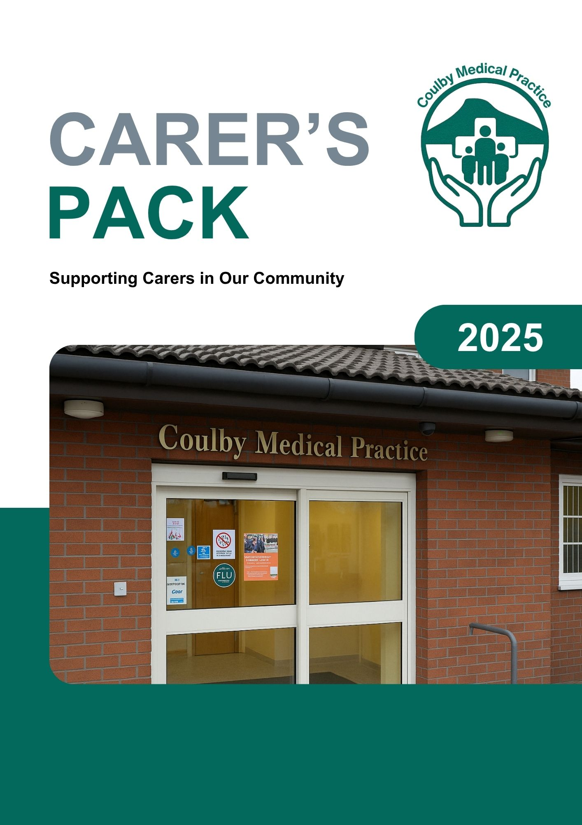
Who are Carers?
‘A Carer is anyone, including children and adults, who looks after a family member, partner or friend who needs help because of their illness, frailty, disability, a mental health problem or an addiction and cannot cope without their support. The care they give is unpaid.’ NHS England definition adopted by South Tees Carers Forum.

Registering as a Carer at the GP Practice
Registering helps us:
- Offer flexible appointments
- Provide annual health checks
- Ensure you're eligible for flu vaccinations
- Tailor support based on your caring role

Your Rights and Support
Support
We Care You Care website: https://wecareyoucare.info
The We Care You Care website provides information, advice and self-signposting for carers in Middlesbrough and Redcar and Cleveland. This website is a fantastic source of information which holds the most up to date information.
Carer's Conversation
Under the Social Care Act 2014, you are entitled to a Carer’s Conversation from a member of the adult health and social care team at Middlesbrough Council, who have a duty of care to you as well as the person(s) you care for. This evaluates your needs and may lead to support such as:
- An assessment of what support you need both emotionally and physically
- Financial support
- Respite care
- Equipment or home adaptations
- Signposting to local carer organisations

A written support plan must be issued to you within 28 days of the carer conversation – please note: It would be really helpful to the practice if your support plan could be shared with the practice to help us support you.

Rights as a Carer
- 5 days unpaid leave
- The right to request flexible working arrangements from day 1 of employment
Local Carer Support Services
Organisation/Service | Eligibility | Contact Details
Carers Together | Carers (aged 18 and over) | 01642 488977  www.carerstogether.co.uk
Next Steps Transition Service Delivered by The Junction Foundation and Carers Together | Carers (aged 15-25) | 01642 756000 or  01642 488977
The Junction Foundation | Young Carers (aged 5-16) | 01642 756000  www.thejunctionfoundation.com
Teesside Mind Carers Service | Carers (aged 18 and over) for positive health and wellbeing support | 01642 257020  www.teessidemind.org.uk  Self-referral form
Middlesbrough Council (Carers Assessment) | Aged 18 and over providing care for somebody in Middlesbrough | 01642 726004  www.middlesbrough.gov.uk
Redcar & Cleveland Council (Carers Assessment) | Aged 18 and over providing care for somebody in Redcar & Cleveland | 01642 065070  www.redcar-cleveland.gov.uk
We Care You Care | Information platform for all carers | www.wecareyoucare.info
Mobilise Middlesbrough | Practical and emotional support for all carers | https://support.mobiliseonline.co.uk/middlesbrough
Carents | Practical advice, emotional support and resources for those taking care of an elderly parent or relative | https://carents.co.uk/
Social Prescribing Service available in all PCN's across South Tees | Aged 18 and over | Referral via GP Practice

Looking After Your Health
- Book an appointment with our practice Health Care Assistant, for a Carer's Health Check, if your caring role is impacting your physical or emotional health.
- Access available services/support for example, The Recovery College through Teesside MIND delivers courses to equip you with coping strategies to help you improve your mental health and wellbeing such as courses in confidence building, coping skills, emotional resilience and the HOPE course (Help to Overcome Problems Effectively for those whose mental health and wellbeing has been effected by cancer).
- Support groups for connection and guidance via We Care You Care.
Emergency Planning
Ask about a Carer Emergency Card as part of your Carer's Conversation, which shows that you are a carer, and someone relies on you for support. If there's an emergency, whereby you cannot provide the support/care the card can be used to ensure the person gets the care they need, whilst you are unable to provide this.
Financial Support
- Carers Allowance
You may be eligible for Carer’s Allowance if you, the person you care for and the type of care you provide meets certain criteria.
The person you care for must already get one of these benefits:
- Personal Independence Payment - daily living component
- Disability Living Allowance - the middle or highest care rate
- Scottish Adult Disability Living Allowance - the middle or highest care rate
- Attendance Allowance
- Pension Age Disability Payment
- Constant Attendance Allowance at or above the normal maximum rate with an Industrial Injuries Disablement Benefit
- Constant Attendance Allowance at the basic (full day) rate with a War Disablement Pension
- Armed Forces Independence Payment
- Child Disability Payment - the middle or highest care rate
- Adult Disability Payment - daily living component at the standard or enhanced rate

If your earnings are £196 or less a week after tax, National Insurance and expenses and you are spending 35+ hours a week caring, you could claim a small contribution of £83.30 per week which may help towards additional costs incurred, such as extra utility costs for additional heating or washing of additional clothes etc. Claiming Carers allowance does NOT mean that you are a paid carer. For further information please visit:
www.gov.uk/carers-allowance
- Attendance Allowance / PIP
For the person you care for if they need help with daily tasks.
www.gov.uk/attenance-allowance/eligibility
- Carers Credit
If you're caring for someone for at least 20 hours per week, you may be able to claim Carers Credit which is a National Insurance credit that helps with gaps in your National Insurance record.
The person you care for must already get one of these benefits:
- Disability Living Allowance - the middle or highest care rate
- Scottish Adult Disability Living Allowance - the middle or highest care rate
- Attendance Allowance
- Constant Attendance Allowance
- Personal Independence Payment daily living part
- Armed Forces Independence Payment
- Child Disability Payment - the middle or highest care rate
- Adult Disability Payment - daily living component at the standard or enhanced rate
- Pension Age Disability Payment
If the person you are caring for does not get one of these benefits, you may still be able to get Carer's Credit. When you apply, fill in the 'Care Certificate' part of the application form and ask a health or social care professional to sign this.
https://www.gov.uk/carers-credit/eligibility

Power of Attorney
A power of attorney simply means a written authorisation to represent or act on another’s behalf in private matters. There are different types of power of attorney.
Ordinary Power of Attorney
This gives another person authority to act on your behalf for a limited period. As soon as you lose mental capacity, the ordinary power of attorney will no longer be valid and expire. This means it's not suitable if you need someone to manage your affairs after you’ve lost the ability to do it yourself.
This option is most useful if you temporarily want someone to make decisions for you – for example, while recovering from an illness. If you chose to you can specify a period of time for an ordinary power of attorney or restrict it to a specific activity. This document does not have to register with the Office of the Public Guardian.
Lasting Power of Attorney
This is the most common form of attorney. It is an ongoing arrangement with no expiry date that allows another person to make decisions on your behalf. Once the document is registered, it can be used immediately, with your permission while you still have the capacity, or it can take effect when you lose the ability to make your own decisions (mental capacity). A LPA has to be registered with the government, via the Office of the Public Guardian, for which there is a charge.

There are two forms of LPA’s:
Property and financial affairs LPA
This gives your attorney the power to make decisions about your money and property, including.
- Managing bank or building society accounts
- Collecting pensions or benefits
- Paying bills
- Selling your home if necessary
Health and welfare LPA
This gives your attorney the power to make decisions about:
- Medical care
- Daily routines (washing, dressing, or eating)
- Moving into a care home
- Life-sustaining medical treatment.
You can choose to make one type or both.
It takes between eight and ten weeks to register a lasting power of attorney.

When do you need a Lasting Power of Attorney?
Putting a LPA in place can give you peace of mind that someone you trust is in charge of your affairs should you not be able to look after them for yourself for whatever reason. If you're facing an illness or believe your mental capacity might be deteriorating, then it is worth thinking about who you would like to handle your affairs. If a LPA isn’t set up in advance, it may lead to complications if you (or a loved one) have difficulties looking after your own affairs in the future, or if you need care or support arrangements.
For further information on Power of Attorney, please access the We Care You Care website: https://wecareyoucare.info/articles/power-of-attorney-information-now-available-on-our-site
National Helplines
- Carers UK: 0808 808 7777 | www.carersuk.org
- Samaritans: 116 123 (24/7 emotional support)
- Age UK: 0800 678 1602 (help for older carers)

Feedback and Involvement
Our Practice named Carer's ambassador is Allanah. If you have any feedback in regard to our practice carer support, please contact Allanah to feedback.
You can also join our Practice Patient Participation Group to help influence the development of and change within Coulby Medical Practice and local health services. If you would like to join the group or discuss this further, then please contact the practice.

