COULBY MEDICAL PRACTICE NEWSLETTER
DECEMBER 2023
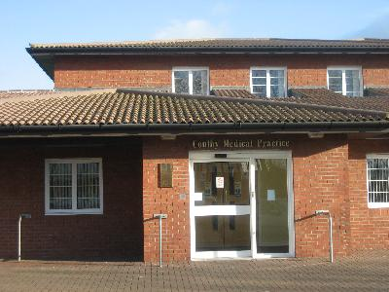
PRACTICE TELEPHONE NUMBER 01642 045830
PRACTICE WEBSITE ADDRESS coulbymedicalpractice.com

“VOICE OF THE PPG”   "WANT TO BE PART OF OUR TEAM?”  Hi my name is Gerry Hart, I am Chair of the Patient Participation Group. We are a group of patients who meet every three months with myself and a representative from the Practice. We share ideas and suggestions and discuss how we can make a difference in the Practice from a patient’s perspective. If you are interested joining our group please enquire at reception.  The PPG agreed that money which was left over from the PPG raffle held earlier in the year was used to purchase another new chair for the waiting area that was taller, with arms on, for patients who had difficulty getting up and down.  This chairs are now in the waiting area for patient use. | PRACTICE NEWS!  As from February 2024 we are to become a Training Practice. This involves a Dr in training who is a qualified hospital Dr learning to be a GP. They will work alongside a GP at the Practice who they can go to for advice. As from February, you may be offered an appointment with the GP registrar if you need medical help.  We also have a Career start Nurse joining our nursing team in Dec '23/Jan '24 (TBC).  Jeanette Oxley, Practice Nurse will be saying Goodbye as she starts her Retirement in December. Although we are sad to see her go, we wish her the very best for the future! We are in the process of recruiting a replacement for Jeanette from the New Year.  Congratulations to Emily, Receptionist who had a baby girl, Ava in November.  We welcome both Allanah (covering maternity leave) & Klaudia into our reception team.  "The DR's & staff at coulby Medical Practice wish you all a very merry Christmas & healthy New Year!"
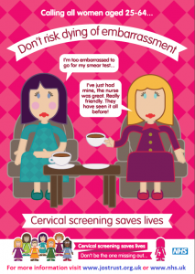  Don’t delay! Book your smear appointment with our Practice Nurse today.  HELPLINE NUMBERS  SAMARITANS 116 123  NATIONAL SUICIDE PREVENTION  HELPLINE UK 0800 689 5652  MIND 0300 123 3393  DEMENTIA CONNECT 0333 150 3456  CRUSE BEREAVEMENT 0808 808 1677  NATIONAL DOMESTIC ABUSE 0808 2000 247  AGE UK 0808 678 1602  CHILDLINE 0800 1111  DEBTLINE 0808 080 4000  ALCOHOL ANNOYMOUS 0800 917 7650  GAMBLING HELPLINE 0808 8020 133  LGBT + VICTIMS & SURVIVOR OF ABUSE & VIOLENCE 0800 999 5428 | Are you up for the Challenge?  Why not take part in local Park Runs. These are held in various locations in Teesside. They are fun and free and welcome all ages and all abilities. Volunteers are always needed! For more information, visit the ParkRun website    eConsult appointment system  Due to new Government contractual requirements and to improve patient access, our appointment system has been changed to the eConsult system. This is now the main way to ask for medical advice/request an appointment.  You will need to submit an eConsult form via our website coulbymedicalpractice.com.  (no password needed). Just click on the GET STARTED button and follow the instructions. eConsult is available from 8am-4pm, Monday- Friday (excluding Bank Holidays). If high volumes of requests are received on the day, then eConsult may be switched off earlier than 4pm but will be available from 8am the next working day.  Appointments for the Nursing team can be booked in advance via your NHS App or by phoning the Practice.    Are you eligible for a free flu Vaccination? If so, book in with our Nurse today! Although we are not offering COVID vaccinations at the Practice, these can still be booked  online or call 119.  